PREDICTING STOCK AND CRYPTO MARKET USING MACHINE LEARNING

A PROJECT REPORT

Submitted by

AMAN GUPTA
(19BCE10289)
VAGHASIA AUM
(19BCE10437)
YASH SAXENA
(19BCE10115)
BOMMAKANTY SATYA SAI ANIRUDH
(19BCE10045)

In partial fulfillment for the award of the degree
Of

BACHELOR OF TECHNOLOGY

in
COMPUTER SCIENCE AND ENGINEERING



SCHOOL OF COMPUTING SCIENCE AND ENGINEERING
VIT BHOPAL UNIVERSITY
KOTHRIKALAN, SEHORE
MADHYA PRADESH - 466114
SEPTEMBER 2022
VIT BHOPAL UNIVERSITY,KOTHRIKALAN, SEHORE
MADHYA PRADESH – 466114
Bonafide Certificate

Certified that this project report titled “PREDICTING STOCK AND CRYPTO MARKET USING MACHINE LEARNING” is the Bonafide work of “AMAN GUPTA (Register No: 19BCE10289), VAGHASIA AUM (Register No: 19BCE10437), YASH SAXENA (Register No: 19BCE10115), BOMMAKANTY SATYA SAI ANIRUDH (Register No: 19BCE10045)” who carried out the project work under my supervision. Certified further that to the best of my knowledge the work reported here does not form part of any other project / research work on the basis of which a degree or award was conferred on an earlier occasion on this or any other candidate.

PROGRAM CHAIR PROJECT GUIDE
Dr. Sandip Mal, Lead Program Chair Dr. Prabu M, Faculty
School of Computer Science and Engineering School of Computer Science and Engineering
VIT BHOPAL UNIVERSITY VIT BHOPAL UNIVERSITY

The Capstone Examination is held on 6th April 2023

Acknowledgement

First and foremost, I would like to thank the Lord Almighty for His presence and immense blessings throughout the project work.
I wish to express my heartfelt gratitude to Dr. Sandip Mal, Head of Department, School of Computer Science and Engineering for much of his valuable support encouragement in carrying out this work.
I would like to thank my internal guide Dr Prabu M, for continually guiding and actively participating in my project, giving valuable suggestions to complete the project work.
I would like to thank all the technical and teaching staff of the School of Computer Science and Engineering, who extended directly or indirectly all support.
Last, but not the least, I am deeply indebted to my parents who have been the greatest support while I worked day and night for the project to make it a success.

Abstract
- Stocks and Crypto are possibly the most popular financial instrument invented for building wealth and are the centerpiece of any investment portfolio. The advances in trading technology have opened up the markets so that nowadays nearly anybody can own them.

- From last few decades, there seen explosive increase in the average person’s interest for stock market. In a financially explosive market, as the stock market, it is important to have a very accurate prediction of a future trend.

- Another popular trend which has increased in past couple of years is investing in crypto. With the start of Bitcoin in 2009 which was the first cryptocurrency ever made, the crypto market gradually grew from there and has an estimated market cap of $891 billion.

- Because of the financial crisis and recording profits, it is compulsory to have a secure prediction of the values of the stocks and crypto. Predicting a non-linear signal requires progressive algorithms of machine learning with help of Artificial Intelligence (AI).

- In this project, use of Machine Learning Algorithm will be emphasized focusing on Long Short-Term Memory (LTSM)
Table of Contents
CHAPTER NO. | TITLE | PAGE NO.
 | List of Abbreviations  Abstract | 3  4
1 | INTRODUCTION | 7
2 | LITERATURE SURVEY | 8
3 | SYSTEM ANALYSIS | 9
4 | SYSTEM DESIGN AND IMPLEMENTATION | 10
5 | FUTURE ENHANCEMENT AND CONCLUSION | 11
 | References | 12
List of Graphs

COMPANY STOCK GRAPHS

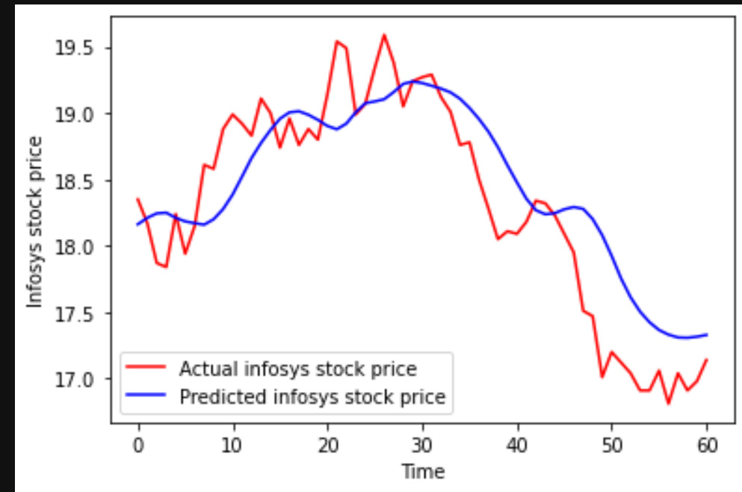

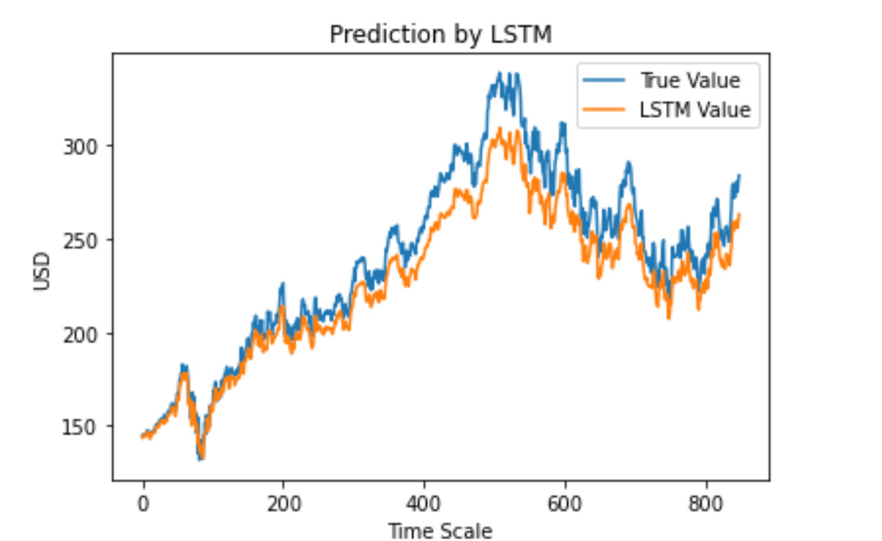
MSFT

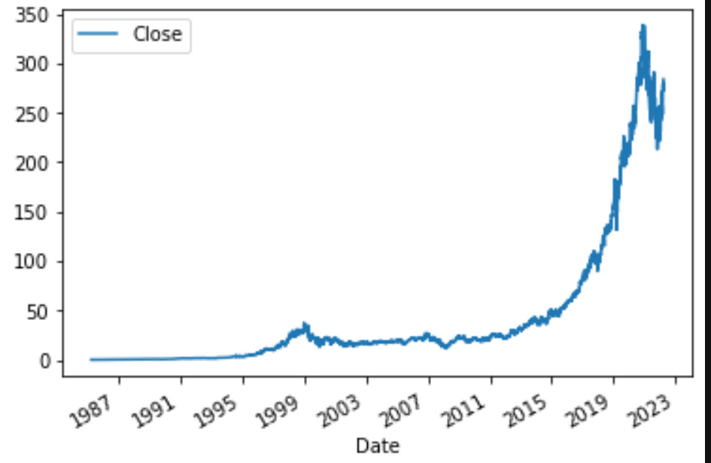
MSFT

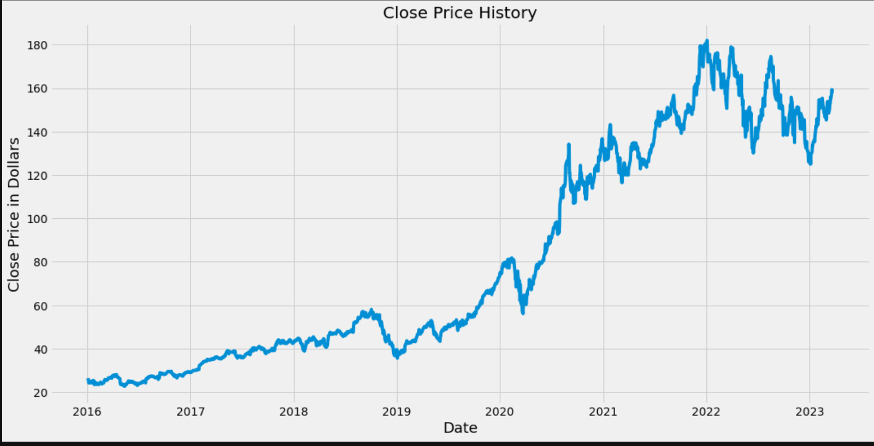
AAPL

CRYPTO STOCK GRAPH
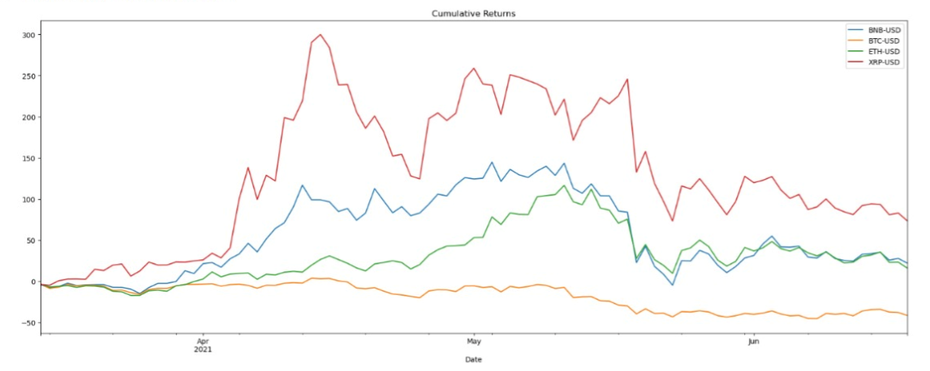

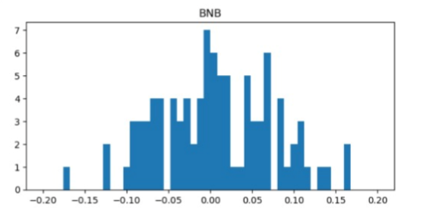

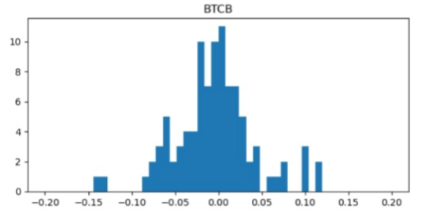

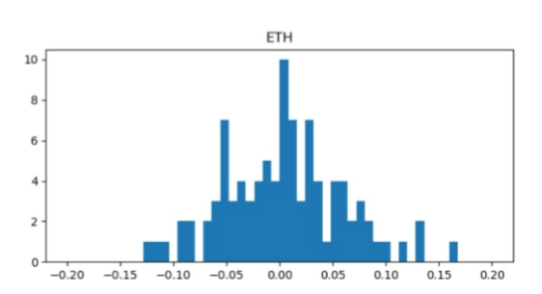

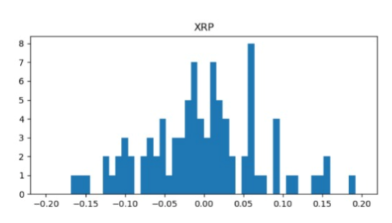

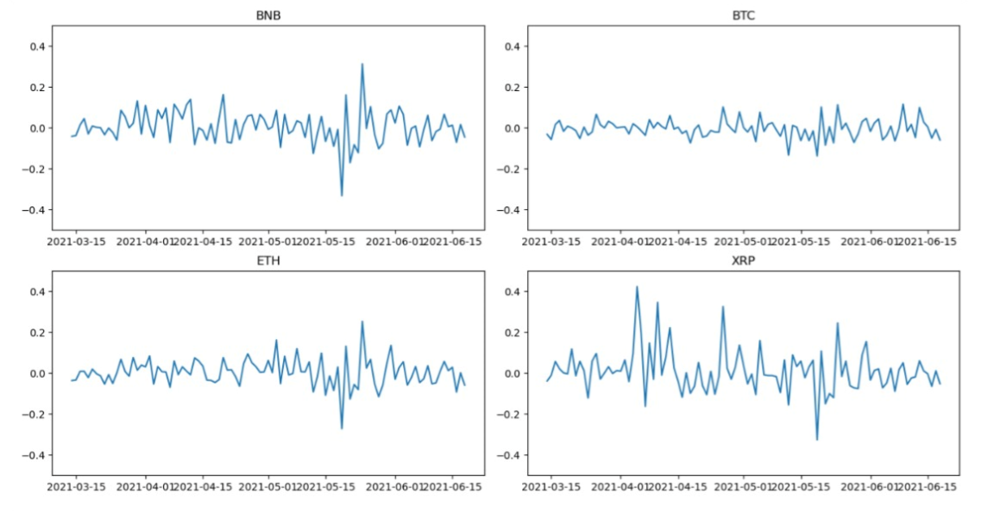

List of symbols, nomenclature and abbreviations used

- LTSM
- RNN
- CNN
- AAPL
- SP500
- MSFT
- INFY
- ETH
- BTC
- BNB
- XRP
- LR

Introduction
As everything in the world runs on money, it is important for us to find another source of incoming apart from our job. What’s better than investing our money in stocks and Crypto. They give us a lot of money back for the little amount you invested in them.

History of stocks goes back to 17th century in Amsterdam where the Amsterdam Stock Exchange is said to have been the first stock exchange to introduce continuous trade in the early 17th century. The process of buying and selling the VOC's shares, on the Amsterdam Stock Exchange, became the basis of the world's first official (formal) stock market.

It was observed that people have started to invest more into stocks due to the recent events which happened with the GameStop’s stock GME, where people made a huge profit from selling their stocks and due to these events more people are getting to know about stock market. In US alone 55% of the adult population have invested in stocks.

Another popular trend which has increased in past couple of years is investing in crypto. With the start of Bitcoin in 2009 which was the first cryptocurrency ever made, the crypto market gradually grew from there and has an estimated market cap of $891 billion.

Main aim of this project is to let people know which company’s stocks and which Cryptocurrency are doing good and which company’s stocks and Crypto are not doing good. The prediction of the stock and Crypto prices of each individual company and Currency will be accomplished using AI and ML. This will enable people to have a clear picture of each company.

Literature Survey
- We had trained the model for predicting the stocks by machine learning and had plotted the data in form of graphs, so as to make it user friendly and understandable.
- We have predicted the future stock and Crypto values using Long Short-Term Memory and random forest classifier. Long Short-Term Memory networks are a special kind of RNN, capable of learning long-term dependencies. They work tremendously well on a large variety of problems, and are now widely used. LSTMs are explicitly designed to avoid the long-term dependency problem.

- Remembering information for long periods of time is practically their default behavior, not something they struggle to learn. All recurrent neural networks have the form of a chain of repeating modules of neural network.
- In standard RNNs, this repeating module will have a very simple structure, such as a single tanh layer.

Project Procedure (Methodology)

Proposed work –

This project attempts to predict the stock value with respect to the stock’s previous
value and trends. It requires historic data of stock market as the project also
emphasizes on data mining techniques
The purposed method for developing the system consists of mainly three main steps. Firstly, data is collected and sorted for relevancy from various sources. Secondly, analysis is carried out on the collected data by examining the current market direction, tracking the industry group and specific companies after which the data is represented and scored accordingly. At last, a model is designed with suitable algorithm which gives the best accurate data and that is chosen to predict the stock value.

Methodology –

Stock market prediction seems a complex problem because there are many factors that have yet to be addressed and it doesn’t seem statistical at first. But by proper use of machine learning techniques, one can relate previous data to the current data and train the machine to learn from it and make appropriate assumptions. Machine learning as such has many models but this paper focuses on two most important of them and made the predictions using them.
Python will be used for this purpose with the special libraries included in it which are- Numpy, Matplotlib and Pandas libraries in Python.

Work Done

- Machine learning will be used to make the predictions which will be done by feeding data to our model and training it by using this data.

- Additionally, the creation and fully completion of the stock portfolio ipynb file will be accomplished using math, NumPy pandas’ libraries.

- A stock Portfolio basically is a collection of stacks that we invest in with the hope of making a profit. That’s because if one sector takes a hit, the investments we hold in other sectors are not necessarily affected.

- Full portfolio consists of various companies and crypto currencies.

- Stocks of Microsoft, Infosys, Apple, Ethereum, Bitcoin, Binance, Ripple are used for our stock portfolio ipynb file.

- The stocks can now be accessed from our website which we have published online.

- Giving the ability to user to see the stock graph between certain dates and see how much volume of Crypto coin and how many stocks were sold between that given time period.

Result and Conclusion

Hereby, it can be proposed that no trading algorithm can be 100% effective, not only 100%, it will typically never be close to 70% but to attain even an accuracy of 40% or 35% is still good sufficient to get a good forecast spread. Model was able to closely forecast the predictable outcome and have coordinated against the company graph. To make our expectation more efficient, it can be done by including bulky data sets that have millions of entries and could train the machine more powerfully. Different activities of stocks can lead to diverse raises or lows in the forecast price.
It can also be determined that in a stock market, there is probable that some companies might not be associated at all, and mostly can be associated to each other, and can help justice movements of stock accordingly, we can scale affairs and see how much in percentages they are correlated.

Website UI
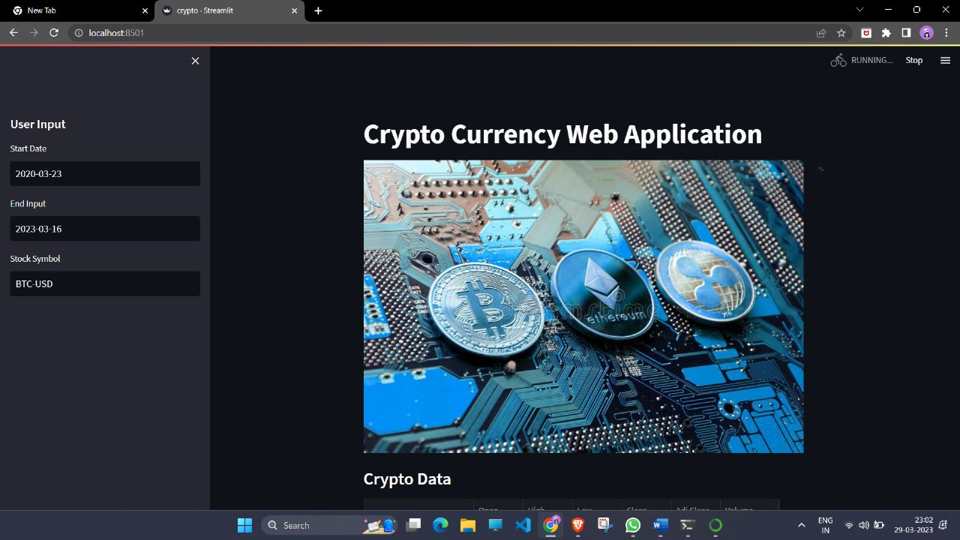
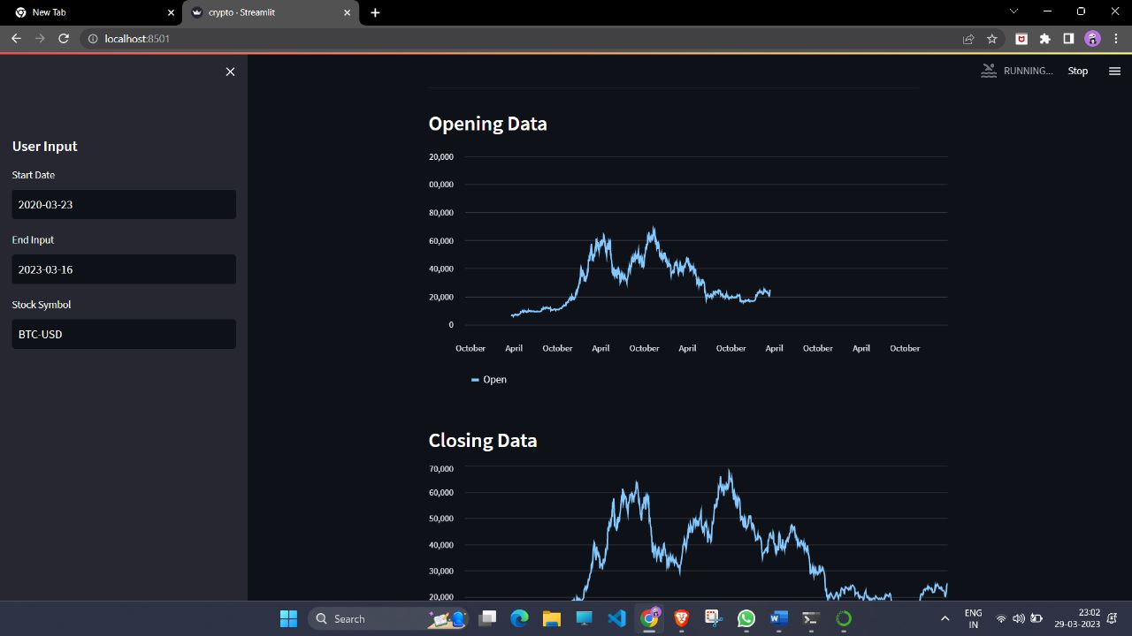
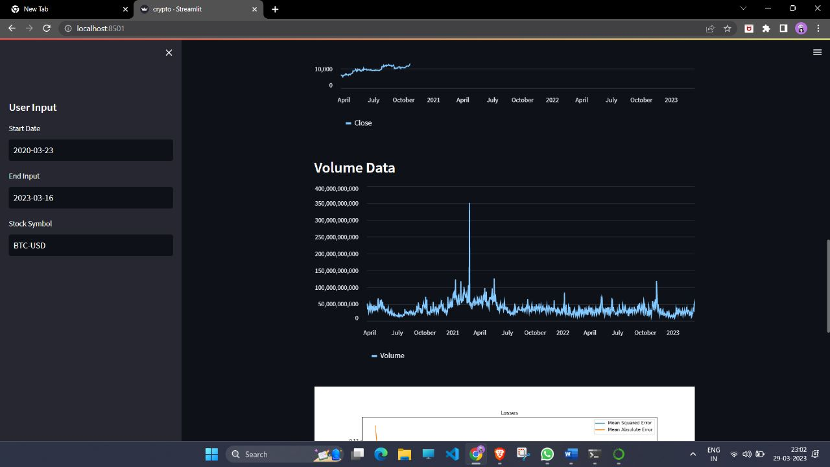
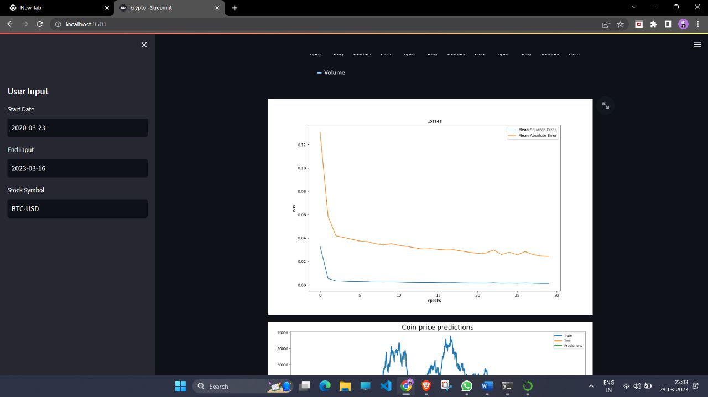

Recommendation for Future Work

For future work, we recommend predicting stock market by a combination of Linear regression, more advanced techniques like Auto ARIMA, and Neural networks. The machine learning model generated by mixture of these combinations will go a long way in predicting the prices of the stock accurately. Since the prices of stock depend on many factors such as news about various factors like demonetization, and merger of companies, and certain factors that cannot be predicted beforehand as well. It would surely help if factors like current economic condition, sentiments about a company are taken into account while training the model.
Lastly, we propose a full-fledged portal and application, where the prices of stock predicted will be shown in real time, and also real time updating of the data along with a utility which signals the investor about when they should invest in a company and when to pull out of it.

References
- https://www.researchgate.net/publication/
- https://pythonprogramming.net
- https://matplotlib.org
- https://www.google.co.in/amp/s/www.geeksforgeeks.org/numpy-in-python-set-1- introduction/amp/
- https://ijarcce.com/upload/2017/may-17/IJARCCE%2078.pdf
- https://www.ripublication.com/ijaer19/ijaerv14n8_24.pdf
- https://www2.cs.uh.edu/~ceick/UDM/Understanding_RNN.pdf
- https://colah.github.io/posts/2015-08-Understanding-LSTMs/
- https://datascience.stackexchange.com/questions/55811/getting-stock-data-in-a-discipline-manner-from-yahoo-finance
- https://link.medium.com/2bhoiqBmQwb
- https://www.sciencedirect.com/science/article/abs/pii/S037704271930398X

